

FINAL PROJECT FILE
SUBJECT – CSE [326]
SECTION – K23WA

TOPIC – Online Coaching and Training Platform
NAME OF FACULTY: Mrs. Nidhi Arora
UID: 28373
SIGN.:
NAME: Piyush Kumar
REG. NO.: 12309135
ROLL NO.: 29
SIGN.:
RECIEVED BY:

SUBMITTED BY:

1
2
TOPIC PAGE NO.

- INTRODUCTION 3

- ACKNOWLEDGEMENT 4

- TECHNOLOGIES USED
- HTML 5
- JAVA SCRIPT 6
- CSS 7

- MODULES 8 -

- WEBSITE SNAPSHOTS 9

- REFRENCES 10

CONTENTS

We are presenting a project on the topic “Online Coaching and Training Platform”. In this project we have tried to give all the important things and information about the project. A project is an activity that helps us to improve our planning and initial thinking ability.
This project which is on the topic “Online Coaching and Training Platform” contains-
- HTML
- JAVA SCRIPT
- CSS
We have all the information in this project by consulting websites, social media, and books.
INTRODUCTION

3
ACKNOWLEDGEMENT
I would like to express my special thanks of gratitude to my teacher Mrs. Nidhi Arora who gave me the golden opportunity to do this wonderful project on the topic. Online Coaching and Training Platform, which also helped me in doing a lot of research and I came to know about many new things I am really thankful to them.

Secondly, I would also like to thank my partners who helped a lot in finalizing this project within the limited time.

Hypertext Markup Language, is a markup language for the web that defines the structure of web pages. It is one of the most basic building blocks of every website, so it’s crucial to learn if you want to have a career in web development. HTML determines the structure of web pages and uses tags to create headings, paragraphs, bolded words, italicized words, and more. HTML elements consist of the opening tag, a character, the content, and a closing tag.
- HTML:
TECHNOLOGIES USED

Script is a dynamic programming language that’s used for web development, in web applications, for game development, and lots more. It allows you to implement dynamic features on web pages that cannot be done with only HTML and CSS. JavaScript is a scripting language that enables you to create dynamically updating content, control multimedia, animate images, and pretty much everything else.

2. JAVA SCRIPT:

3. CSS:

CSS stands for Cascading Style Sheets. It is a style sheet language used to describe the look and formatting of a document written in markup language, such as HTML. CSS provides an additional feature to HTML and is generally used with HTML to change the style of web pages and user interfaces. CSS style definitions are saved in external CSS files, so it is possible to change the entire website by changing just one file. CSS provides more detailed attributes than plain HTML to define the look and feel of the website.

<!DOCTYPE html>
<html lang="en">
<head>
<meta charset="UTF-8">
<meta name="viewport" content="width=device-width, initial-scale=1.0">
<link rel="stylesheet" href="style.css">
<title>Tech Learn</title>
</head>
<body>
<header>
<h1>Tech Learn</h1>
</header>

INDEX FILE:
MODULES

<main id="course-list" class="container">
</main>

<footer>
<p>&copy; 2023 Tech Learn</p>
</footer>

<script src="main.js"></script>
</body>
</html>

body {
font-family: 'Arial', sans-serif;
margin: 0;
padding: 0;
background-color: #f4f4f4;
}

header {
background-color: #333;
color: white;
padding: 20px;
text-align: center;
}

.container {
display: flex;
flex-wrap: wrap;
justify-content: space-around;
}

.course {
width: 300px;
background-color: white;
box-shadow: 0 0 10px rgba(0, 0, 0, 0.1);
margin: 20px;
padding: 15px;
text-align: center;
border-radius: 8px;
transition: transform 0.3s ease-in-out;
}

.course:hover {
transform: scale(1.05);
}

.course h3 {
color: #333;
}

.course p {
color: #666;
}

button {
background-color: #4CAF50;
color: white;
border: none;
padding: 8px 16px;
text-align: center;
text-decoration: none;
display: inline-block;
font-size: 14px;
cursor: pointer;
border-radius: 4px;
}

footer {
background-color: #333;
color: white;
text-align: center;
padding: 10px;
position: fixed;
width: 100%;
bottom: 0;
}

STYLE FILE:

.course {
width: 300px;
background-color: white;
box-shadow: 0 0 10px rgba(0, 0, 0, 0.1);
margin: 20px;
padding: 15px;
text-align: center;
border-radius: 8px;
transition: transform 0.3s ease-in-out;
}

.course:hover {
transform: scale(1.05);
}

.course h3 {
color: #333;
}

.course p {
color: #666;
}

button {
background-color: #4CAF50;
color: white;
border: none;
padding: 8px 16px;
text-align: center;
text-decoration: none;
display: inline-block;
font-size: 14px;
cursor: pointer;
border-radius: 4px;
}

footer {
background-color: #333;
color: white;
text-align: center;
padding: 10px;
position: fixed;
width: 100%;
bottom: 0;
}

button {
background-color: #4CAF50;
color: white;
border: none;
padding: 8px 16px;
text-align: center;
text-decoration: none;
display: inline-block;
font-size: 14px;
cursor: pointer;
border-radius: 4px;
}
footer {
background-color: #333;
color: white;
text-align: center;
padding: 10px;
position: fixed;
width: 100%;
bottom: 0;
}

function createCourseCard(course) {
const courseCard = document.createElement('div');
courseCard.classList.add('course');
courseCard.innerHTML = `
<img src=${course.image} width="90">
<h3>${course.title}</h3>
<p>Instructor: ${course.instructor}</p>
<button onclick="window.location.href='form.html'">Enroll</button>
`;
return courseCard;
}

function displayCourses() {
const courseList = document.getElementById('course-list');
courses.forEach(course => {
const courseCard = createCourseCard(course);
courseList.appendChild(courseCard);
});
}

function enroll(courseId) {
alert(`Enrolled in course with ID: ${courseId}`);
}

window.onload = displayCourses;

MAINS.JS:

function enroll(courseId) {
alert(`Enrolled in course with ID: ${courseId}`);
}

window.onload = displayCourses;

FORMS:
<!DOCTYPE html>
<html lang="en">
<head>
<meta charset="UTF-8">
<meta name="viewport" content="width=device-width, initial-scale=1.0">
<style type="text/css">
body {
font-family: 'Arial', sans-serif;
margin: 0;
padding: 0;
background-color: #f4f4f4;
}
.container {
max-width: 600px;
margin: 50px auto;
background-color: #fff;
padding: 20px;
border-radius: 8px;
box-shadow: 0 0 10px rgba(0, 0, 0, 0.1);
}

h1 {
text-align: center;
color: #333;
}

form {
display: grid;
gap: 15px;
}

label {
font-weight: bold;
margin-bottom: 5px;
}

input,
textarea {
width: 100%;
padding: 8px;
box-sizing: border-box;
border: 1px solid #ccc;
border-radius: 4px;
}

button {
background-color: #4CAF50;
color: white;
border: none;
padding: 10px 20px;
text-align: center;
text-decoration: none;
display: inline-block;
font-size: 16px;
cursor: pointer;
border-radius: 4px;
}

button:hover {
background-color: #45a049;
}

</style>
<title>Interactive Form</title>
</head>
<body>
<div class="container">
<h1>Contact Us</h1>
<form id="contactForm">
<label for="fullName">Full Name:</label>
<input type="text" id="fullName" name="fullName" required>

<label for="email">Email:</label>
<input type="email" id="email" name="email" required>

<label for="phone">Phone No:</label>
<input type="phone" id="phone" name="phone" required>

<button type="submit" onclick="show()">Submit</button>
</form>
</div>

<script type="text/javascript">
function show()
{
alert('Congratulations '+document.getElementById('fullName').value+'. You will receive a mail on '+document.getElementById('email').value)+' shortly.';
}
</script>
</body>
</html>
h1 {
text-align: center;
color: #333;
}
form {
display: grid;
gap: 15px;
}
label {
font-weight: bold;
margin-bottom: 5px;
}
input,
textarea {
width: 100%;
padding: 8px;
box-sizing: border-box;
border: 1px solid #ccc;
border-radius: 4px;
}

button {
background-color: #4CAF50;
color: white;
border: none;
padding: 10px 20px;
text-align: center;
text-decoration: none;
display: inline-block;
font-size: 16px;
cursor: pointer;
border-radius: 4px;
}

button:hover {
background-color: #45a049;
}

</style>
<title>Interactive Form</title>
</head>
<body>
<div class="container">
<h1>Contact Us</h1>
<form id="contactForm">
<label for="fullName">Full Name:</label>
<input type="text" id="fullName" name="fullName" required>

<label for="email">Email:</label>
<input type="email" id="email" name="email" required>

<label for="phone">Phone No:</label>
<input type="phone" id="phone" name="phone" required>

<button type="submit" onclick="show()">Submit</button>
</form>
</div>

<script type="text/javascript">
function show()
{
alert('Congratulations '+document.getElementById('fullName').value+'. You will receive a mail on '+document.getElementById('email').value)+' shortly.';
}
</script>
</body>
</html>

button {
background-color: #4CAF50;
color: white;
border: none;
padding: 10px 20px;
text-align: center;
text-decoration: none;
display: inline-block;
font-size: 16px;
cursor: pointer;
border-radius: 4px;
}

button:hover {
background-color: #45a049;
}

</style>
<title>Interactive Form</title>
</head>
<body>
<div class="container">
<h1>Contact Us</h1>
<form id="contactForm">
<label for="fullName">Full Name:</label>
<input type="text" id="fullName" name="fullName" required>

<label for="email">Email:</label>
<input type="email" id="email" name="email" required>

<label for="phone">Phone No:</label>
<input type="phone" id="phone" name="phone" required>

<button type="submit" onclick="show()">Submit</button>
</form>
</div>

<script type="text/javascript">
function show()
{
alert('Congratulations '+document.getElementById('fullName').value+'. You will receive a mail on '+document.getElementById('email').value)+' shortly.';
}
</script>
</body>
</html>
<body>
<div class="container">
<h1>Contact Us</h1>
<form id="contactForm">
<label for="fullName">Full Name:</label>
<input type="text" id="fullName" name="fullName" required>

<label for="email">Email:</label>
<input type="email" id="email" name="email" required>

<label for="phone">Phone No:</label>
<input type="phone" id="phone" name="phone" required>

<button type="submit" onclick="show()">Submit</button>
</form>
</div>

<script type="text/javascript">
function show()
{
alert ('Congratulations '+document.getElementById('fullName').value+'. You will receive a mail on '+document.getElementById('email').value)+' shortly.';
}
</script>
</body>
</html>

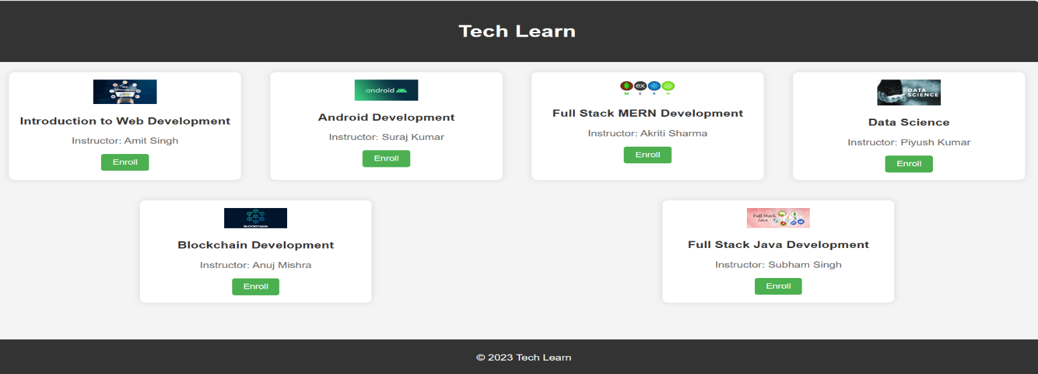
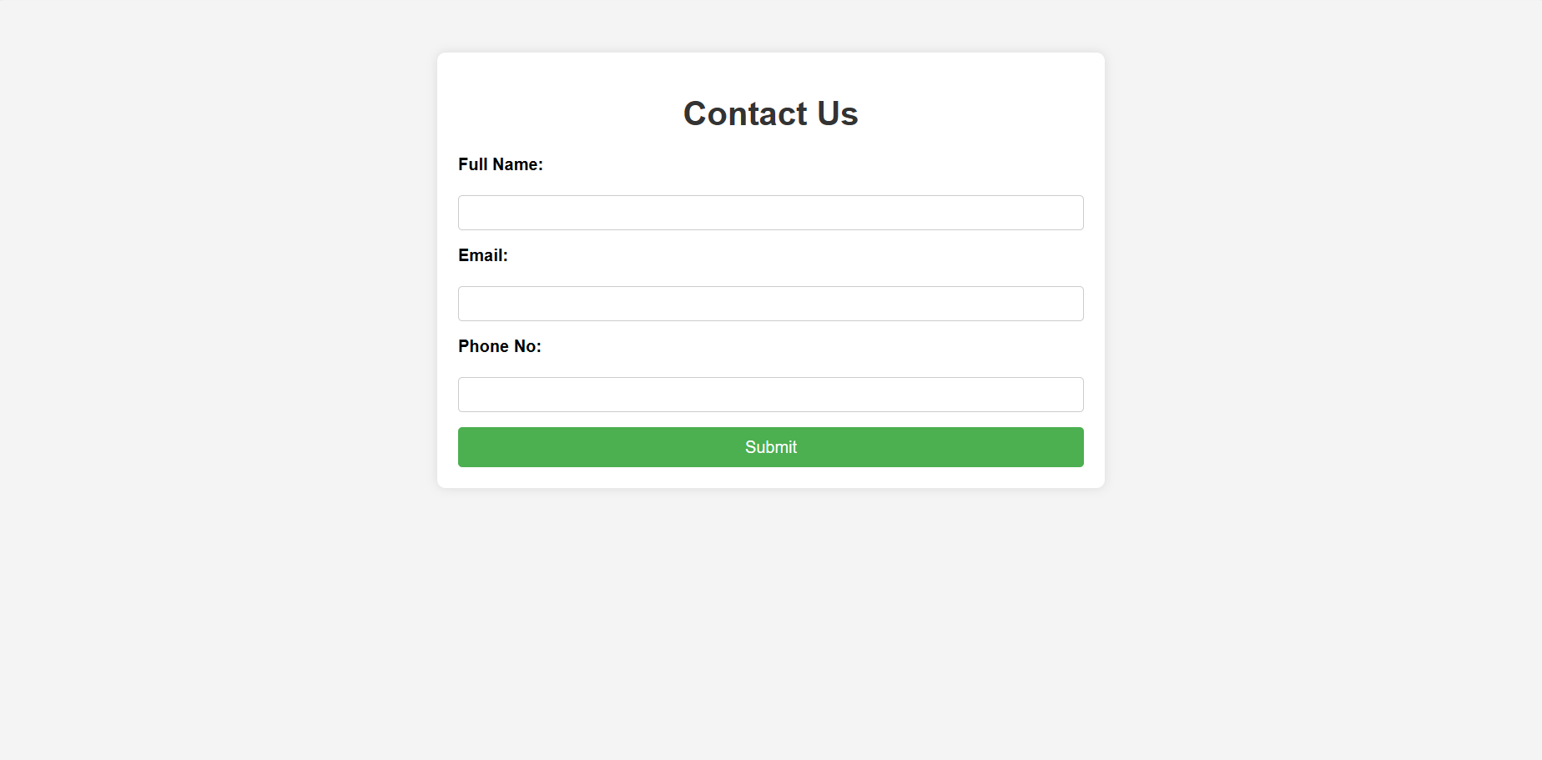
WEBSITE SNAPSHOTS:

- How To Create a Free Website (w3schools.com)

- How to Make a Website | Step-By-Step Guide (websitesetup.org)

- 5 Easiest Website Builders for Beginners 2023 (tech.co)

- How to Create a Website From Scratch (Step-By-Step Beginner’s Guide) | Berkeley Boot Camps
REFRENCES

